AGE AND CEFTAZIDIME (PSEUDOMONAS)

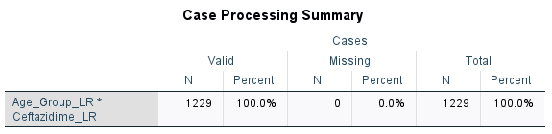

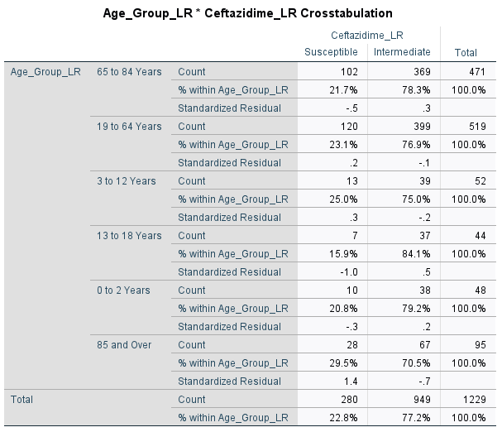

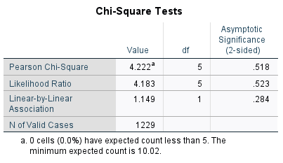

GENDER AND CEFTAZIDIME (PSEUDOMONAS)

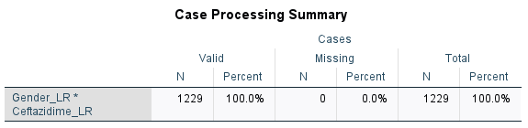

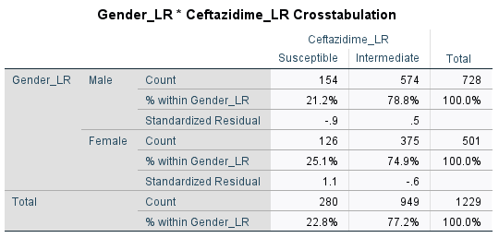

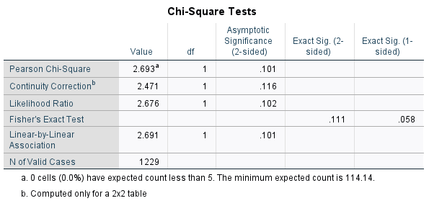

COUNTRY AND CEFTAZIDIME (PSEUDOMONAS)

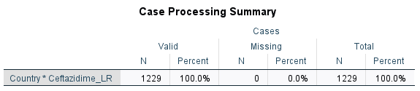

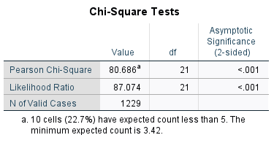

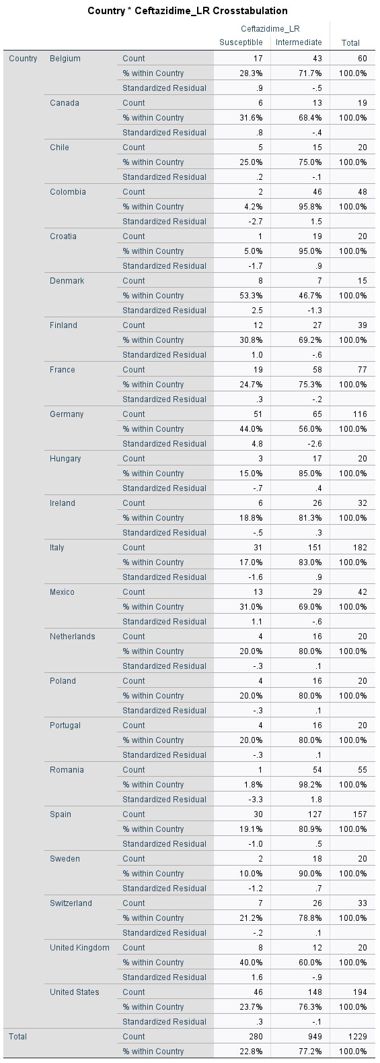

GENDER AND MEROPENEM (PSEUDOMONAS)

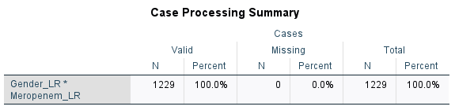

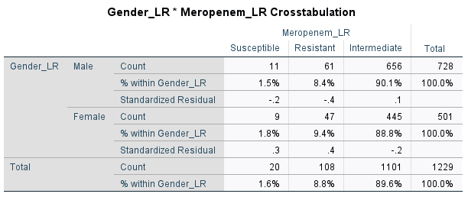

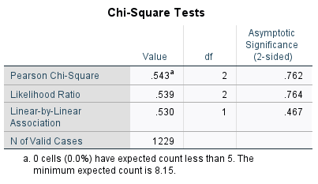

AGE AND MEROPENEM (PSEUDOMONAS)

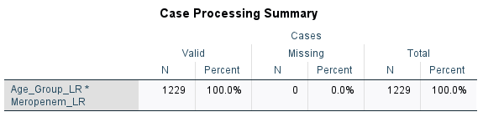

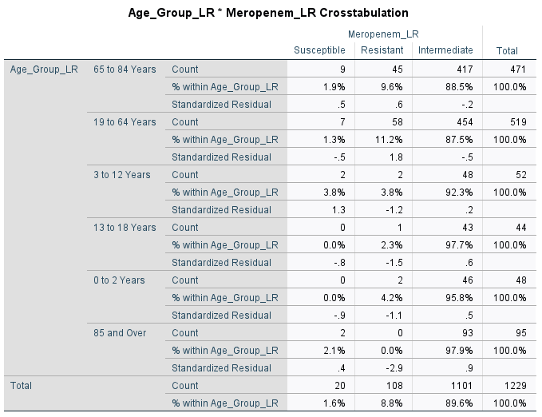

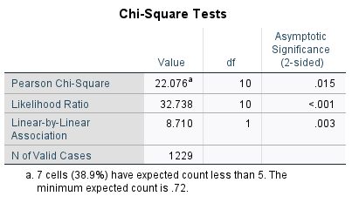

COUNTRY AND MEROPENEM (PSUEDOMONAS)

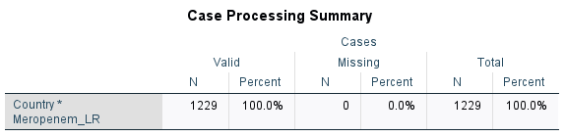

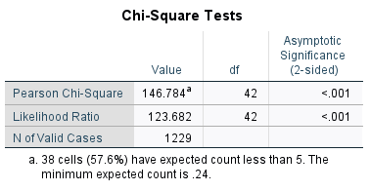

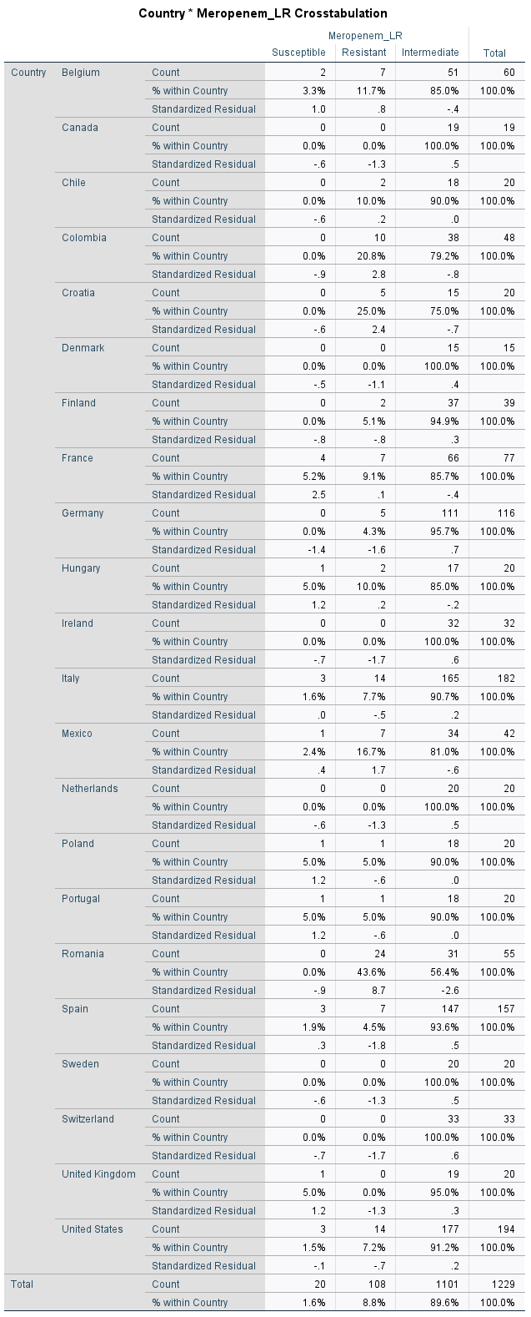

GENDER AND LEVOFLOXACIN (PSEUDOMONAS)

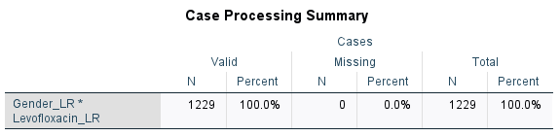

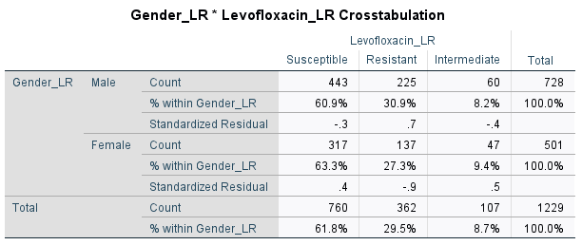

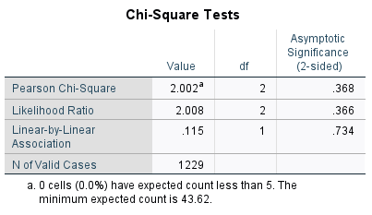

AGE AND LEVOFLOXACIN (PSEUDOMONAS)

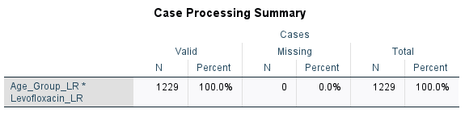

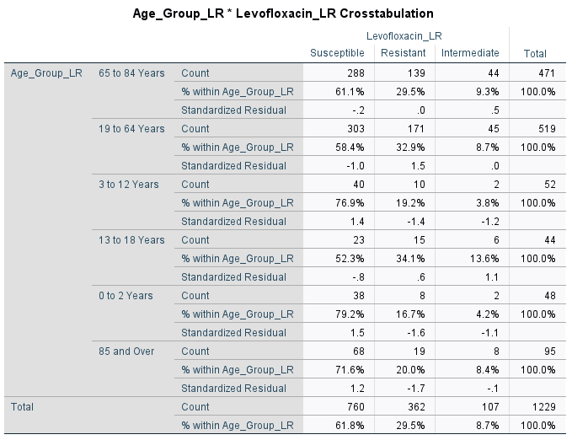

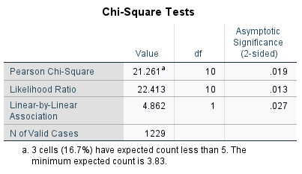

COUNTRY AND LEVOFLOXACIN (PSEUDOMONAS)

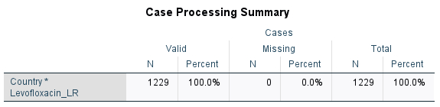

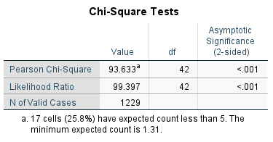

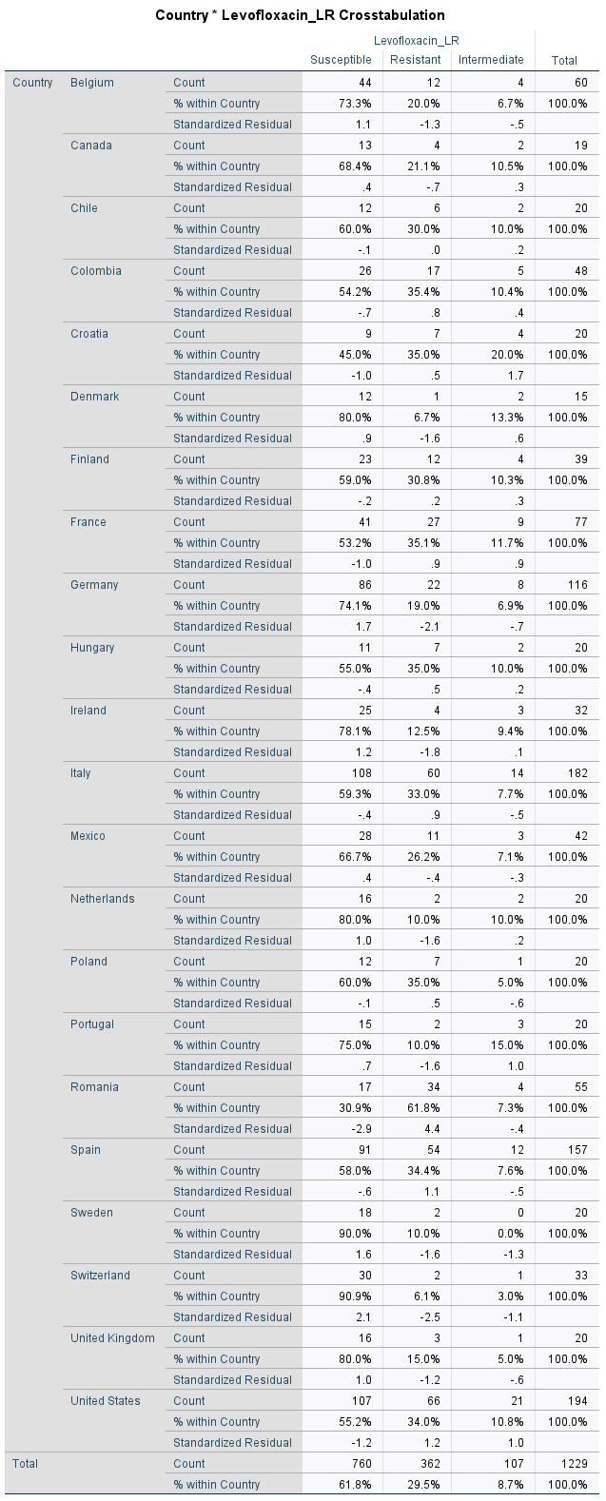

GENDER AND PIPERACILIN (PSEUDOMONAS)

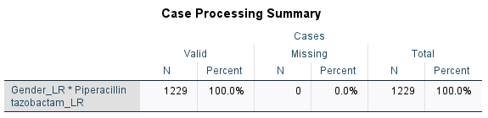

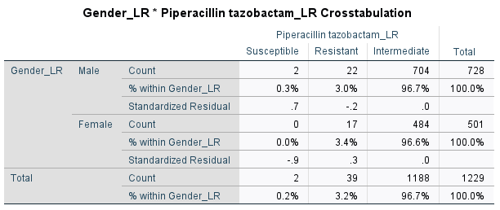

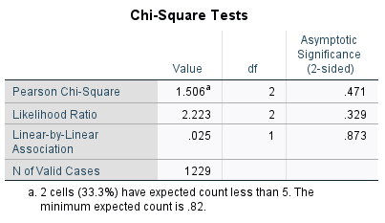

AGE AND PIPERACILIN (PSEUDOMONAS)

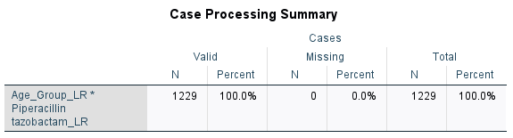

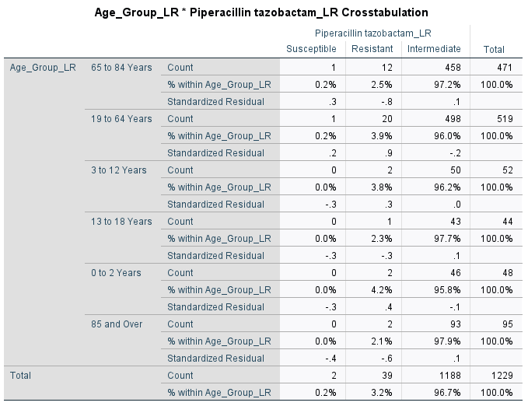

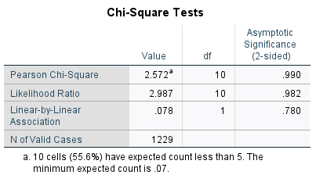

COUNTRY AND PIPERACILIN (PSEUDONOMAS)

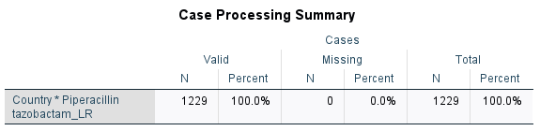

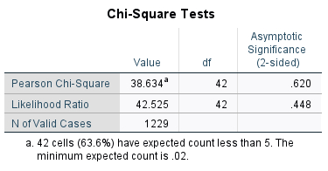

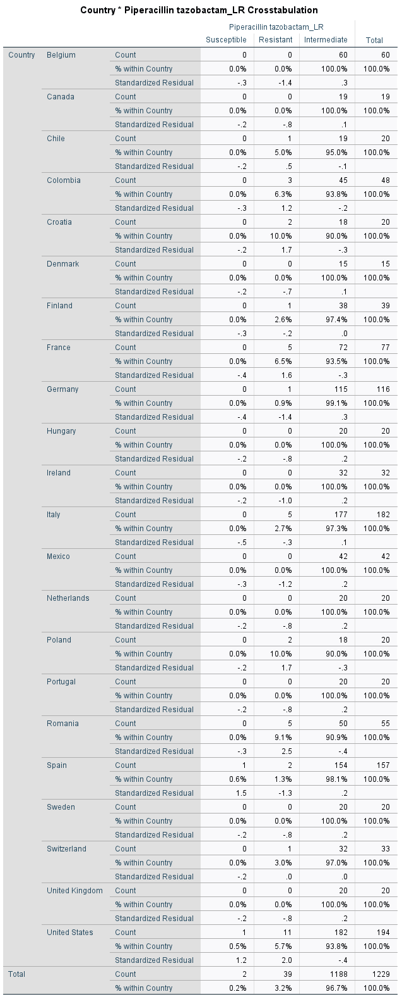

GENDER AND LEVOFLOXACIN (STAPHYLOCOCUS)

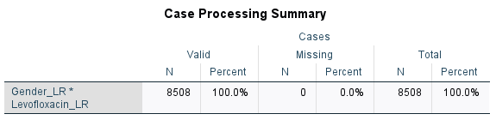

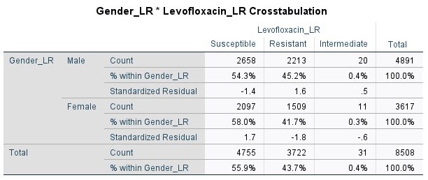

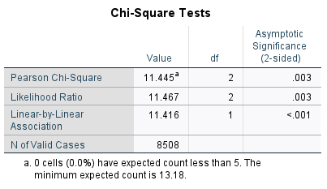

AGE AND LEVOFLOXACIN (STAPHYLOCOCCUS)

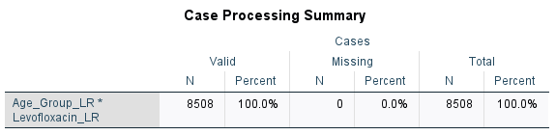

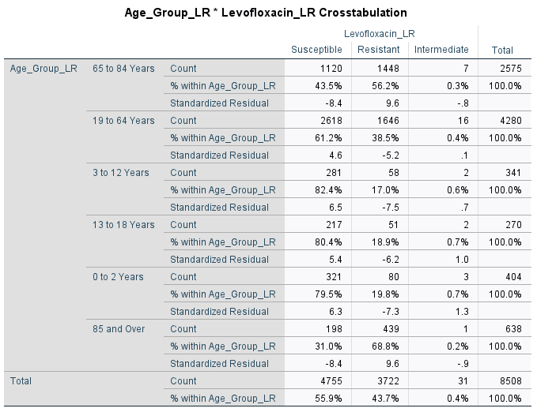

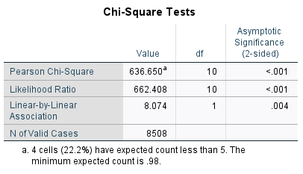

COUNTRY AND LEVOFLOXACIN (STAPHYLOCCOCUS)

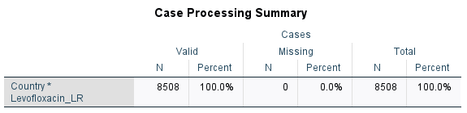

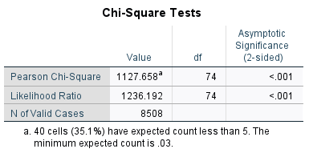

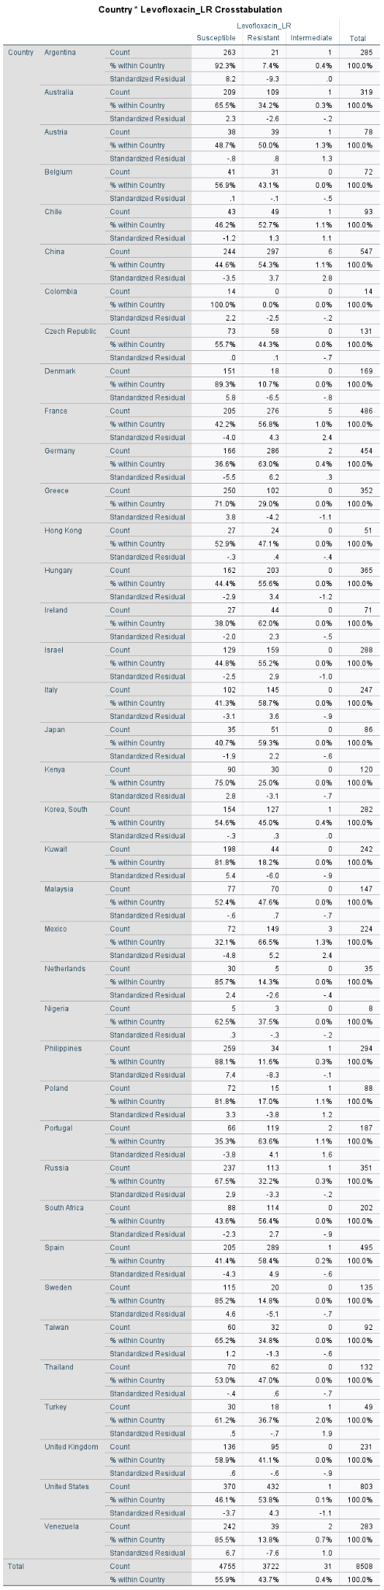

GENDER AND MINOCYCLINE (STAPHYLOCOCCUS)

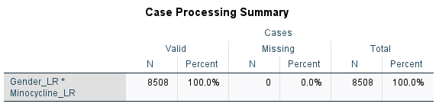

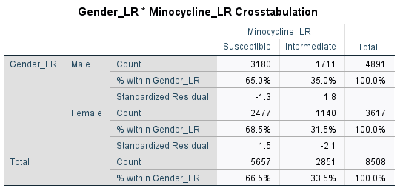

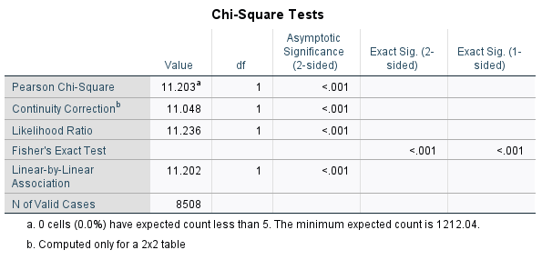

AGE AND MINOCYCLINE (STAPHYCOCCUS)

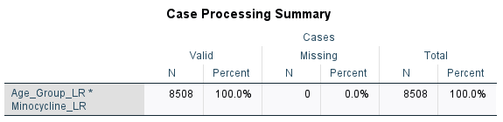

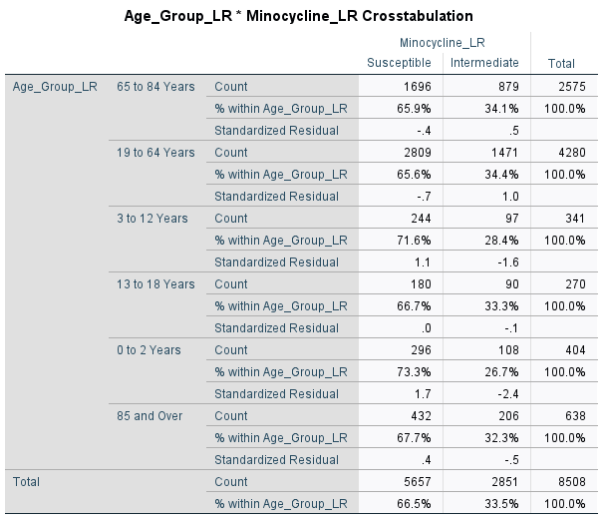

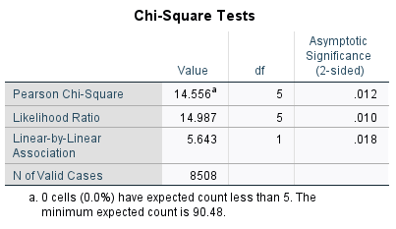

COUNTRY AND MINOCYCLINE (STAPHYLOCOCCUS)

